- Created a new directory locally
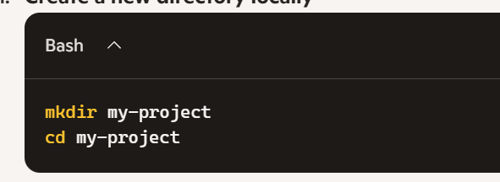
Populated with script file
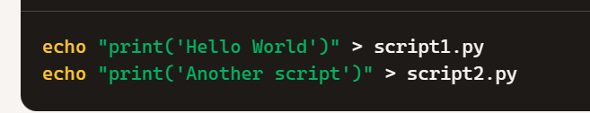

Empty repository
